The paper by Wang et al. (2023) introduces a novel approach, TPE-XGBoost, for transformer fault diagnosis using incomplete data. The methodology involves Bayesian optimization to tune the XGBoost model's hyperparameters, demonstrating superior performance compared to other machine learning algorithms. The method's strength lies in its ability to handle incomplete datasets effectively, as evidenced by its robust performance. However, a limitation is observed in reduced diagnostic accuracy when the data missing rate exceeds 20%, indicating the need for further improvement, especially for cases with a high missing rate exceeding 30% (Wang et al., 2023).

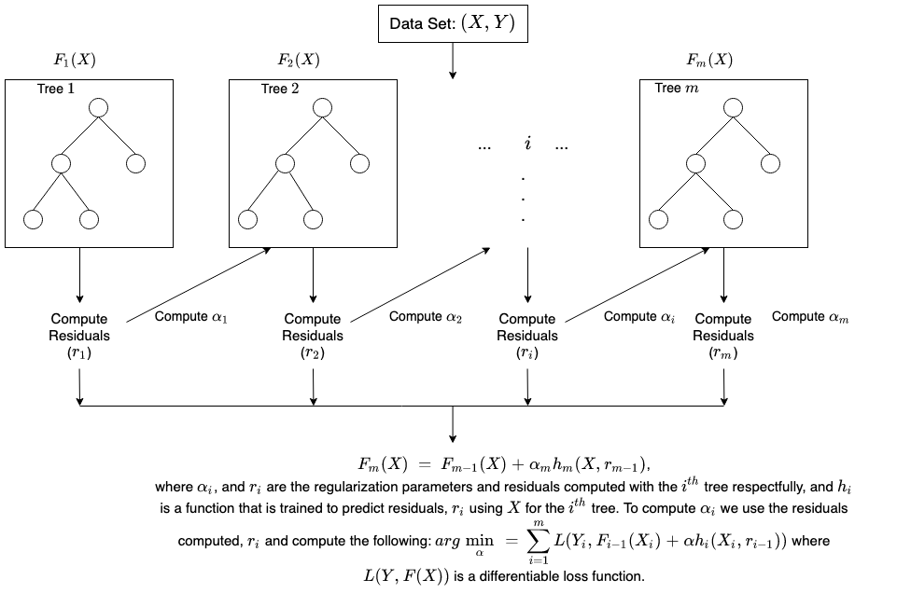

Absolutely, I’d be happy to explain the XGBoost algorithm in a similar manner.

XGBoost, short for “Extreme Gradient Boosting”, is a powerful ensemble learning method that uses gradient boosting frameworks at its core. It’s designed for speed and performance. XGBoost can be used for both Classification and Regression tasks in Machine Learning, making it a versatile tool for predictive modeling.

The name “XGBoost” refers to the algorithm’s procedure of combining predictions from a set of simpler models, known as “weak learners”. In the case of XGBoost, these weak learners are decision trees. The algorithm iteratively adds new trees to the model to correct the errors made by the existing trees, which are built under constraints to keep them simple.

In the context of classification, XGBoost begins by initializing the model with a single tree, whose predictions can be as simple as the average of the target values. It then calculates the residuals, which are the differences between the observed and predicted values of the target variable. A new tree is fit to these residuals, rather than the original target variable, and this process is repeated until a specified number of trees have been added, or no further improvements can be made.

The final prediction is a weighted sum of the predictions made by all the individual trees. The weights, also known as “boosting weights”, are assigned to each tree during the training process based on how well they improve the overall model’s accuracy.

In the context of regression, XGBoost identifies complex structures in the data by constructing decision trees under the gradient boosting framework. Each tree is built to predict the residuals or errors of the previous tree. The final prediction is the sum of the predictions from all individual trees.

The mathematical representation of the XGBoost prediction model for a given sample is:

y^​(x)=k=1∑K​fk​(x)

Here, fk​(x) represents the prediction of the k-th decision tree for sample x.

XGBoost also incorporates several regularization parameters to prevent overfitting, making it a robust and reliable algorithm for a wide range of datasets and prediction tasks.

I hope this explanation provides a clear understanding of the XGBoost algorithm. Let me know if you need further assistance! 😊

Sure, I can add more details to your explanation of the Random Forest algorithm. Here’s a revised version:

**Random Forest Algorithm**

**Classification**

The Random Forest algorithm is a supervised learning technique that can be used for both classification and regression tasks. In the context of classification, the algorithm begins by randomly sampling subsets of the training data with replacement. For each subset, decision trees are constructed.

During the construction of these trees, a subset of features is randomly selected at each node. The optimal feature and split point are chosen based on their ability to minimize the Gini impurity after splitting. Gini impurity is a measure of the uncertainty or impurity of a set of samples, with lower values indicating purer nodes (i.e., more homogeneous classes).

The Gini impurity, denoted asGini(D), for a datasetDwithCclasses is calculated using the formula:

Gini(D) = 1 - \sum_{i=1}^{C} p_i^2

Here,p_iis the probability of classiin nodeD.

After building multiple decision trees, each tree “votes” for a class, and the final predicted class for a sample is determined by the mode of all the predicted classes by the individual trees.

One of the key advantages of Random Forest in classification tasks is its ability to handle a large number of features and deal with unbalanced datasets. It also provides a measure of feature importance, which can be useful for feature selection.

**Regression**

Random Forest regression follows a similar procedure but is tailored for predicting continuous target variables. Again, subsets of the training data are randomly sampled with replacement, and decision trees are built using a subset of features at each node. The splitting criterion, such as maximizing the decrease in Gini impurity, is used to determine the best feature and split point.

However, instead of predicting classes, each tree predicts continuous values. The predicted value for a sample is the average of predictions by all the individual trees, calculated as:

\hat{y}(x) = \frac{1}{k} \sum_{i=1}^{k} \hat{y}_i(x)

Here,\hat{y}_i(x)represents the predicted value by thei-th decision tree for samplex. This averaging process ensures that the Random Forest ensemble provides robust predictions for regression tasks by leveraging the diversity of multiple decision trees.

In regression tasks, Random Forest can handle non-linear relationships between features and the target variable, and it is robust to outliers in the dataset. Like in classification, it also provides a measure of feature importance.

**Hyperparameters**

The performance of the Random Forest algorithm can be influenced by several hyperparameters, including the number of trees in the forest (n_estimators), the maximum depth of the trees (max_depth), the minimum number of samples required to split an internal node (min_samples_split), and the number of features to consider when looking for the best split (max_features). Tuning these hyperparameters appropriately can help improve the model’s performance.

**Limitations**

While Random Forest is a powerful algorithm, it has some limitations. It can be computationally expensive and slow to train if the number of trees is very large. Also, it may not perform well on very high dimensional and sparse data, such as text data. Despite these limitations, Random Forest is a versatile and widely used algorithm due to its good performance, interpretability, and ease of use.